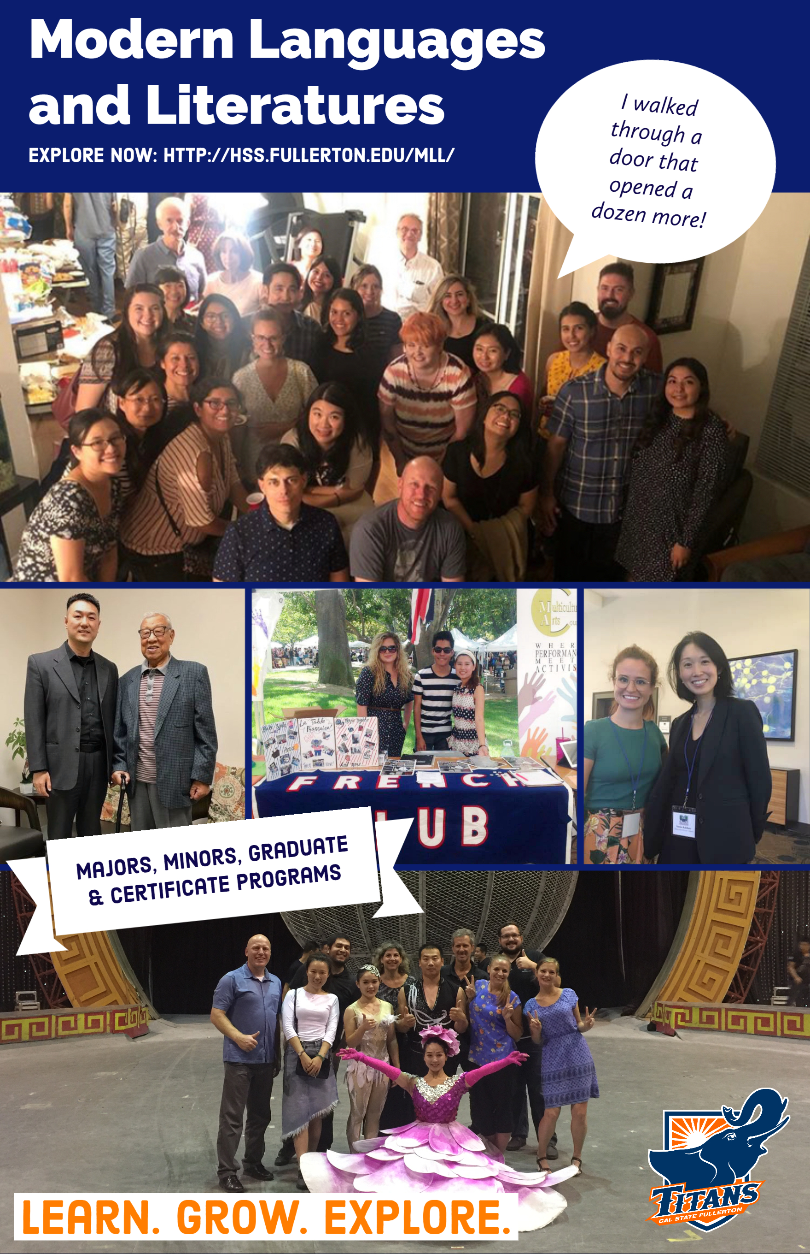

Modern Languages and Literatures

Explore now: http://hss.fullerton.edu/mll/
I walked through a door that opened a dozen more!
Majors, minors, graduate and certificate programs
Learn. Grow. Explore.

