Dear First Name,

All of us here in the History Department are excited to welcome you to Cal State Fullerton. We can’t wait to see you in our classrooms, talk to you in our offices, and show you all the ways in which history makes sense of the world, enriches your lives, and builds your careers.
We hope you’ll join us for a welcome and introduction at the in-person Experience CSUF: Become a Titan event on Saturday, April 9th any time between 9am and 2pm in front of the Humanities Building on the Cal State Fullerton campus.

To learn more about our History Department, watch this two-minute video or read our welcome message below.
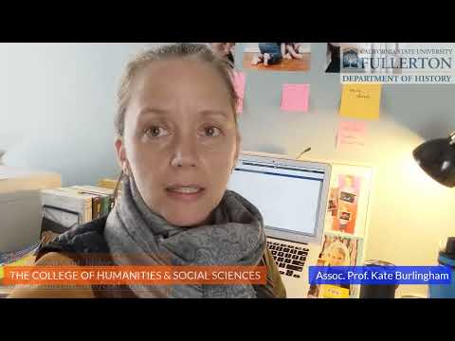
Here at Cal State Fullerton, we help you think beyond your graduation and prepare you for meaningful professional lives afterwards. From archives, museums, national parks and schools to all levels of government, media, business, and law - our alumni work in almost 100 different careers.
At Cal State Fullerton’s Center for Oral and Public History, you have the chance to learn historical fieldwork at one of the nation’s leading public history research centers. In addition, we currently place our students at over forty different internship locations. To find what you can do with a Titan History degree, follow this link:
https://spark.adobe.com/page/MPEdb/.
You can also learn more about your future history faculty, fellow students, and the Department staff on our social media.
www.instagram.com/csuf_history www.facebook.com/CSUFHistory twitter.com/csuf_history
As a History major at CSUF, you will find support and help beyond the History Department.
In the College of Humanities and Social Sciences, the Student Success Team provides you with resources and academic advising. The student success team also provides you with important information on things like our study abroad and the D.C. Scholars Program, tips on ways to get involved in clubs and organizations, and so much more.
http://hss.fullerton.edu/student_success_team/index.aspx
See also the Prospective Student Page for the College of Humanities and Social Sciences
https://hss.fullerton.edu/wtcsufd/index.aspx

Here at Cal State Fullerton’s History Department, we care about your education, make sure you get lots of hands-on-experience, work in teams, and practice crucial skills for the future--all from accomplished faculty who have won numerous awards for their teaching, research, and publications.
If we can do anything to help, please feel free to reach out to History Department Chair Jasamin Rostam-Kolayi at jrostam@fullerton.edu.
We hope you’ll join us for the in-person Experience CSUF: Become a Titan event on Saturday, April 9th.

Prof. Volker Janssen, Vice Chair
Prof. Jasamin Rostam-Kolayi, Chair

