CSUF College of Humanities & Social Sciences
Inter-Club Council Meeting
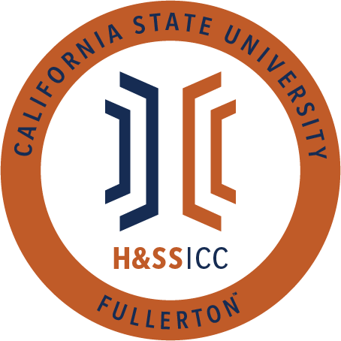

September 13th, 2019 11:00 A.M.
TSU Legislative Chambers

Meeting called by:
Jacqueline Montero, Chair

Type of meeting:
Regular

Attendees:
Council Representatives, Executive Officers, General Public
Absent:
Late:

Agenda Topics:

- Call to Order / Roll Call 11:20am
- Approval of Minutes
  - Philosophy Approves
  - CJSA Seconds
- Approval of Agenda
  - PDSA Approves
  - SAAAS seconds
- Public Speakers
  - Aaron Aguilar (pronouns: he, him, himself) – ASI Student Body President
    - University Wide Committees
      - Students can join committees in order to have a say in important decisions made concerning students, including diversity initiatives, parking & transportation, and academics.
      - Time commitments for students:
        - Orientation, monthly meetings (approximately 2-2.5 hours each) scheduled around students’ availability
      - Student Fee Advisory Committee & Student Success Initiatives Committees
    - ASI Scholarships are now available, with a deadline of 10/9.
- Budget
  - 8074 – Contracts, Fees and Rentals: $ 16,000
  - 8077 – Travel: $ 9,000
- Reports
- Chair – Jacqueline Montero
  - Update to Office Hours
    - Wednesday from 1:30-2:30, Thursday & Friday 9-10am
- Vice Chair – Ginny Oshiro
  - Ginny will not be here for next week’s meeting but will be in office hours.
  - Reminder for those proposing next week that packets are due on Tuesday morning. Physical packets are turned into GH211b, digital packets are emailed to Chair & DOA.
- Director of Administration – Gabriella Cuna
  - Not present
- Director of Public Relations – Leslie Rodriguez
  - If you’ve not been added to the GroupMe yet, please see Leslie after the meeting.
  - Please follow social media for updates.
- Social Justice Facilitator – Valarie Segovia
  - US Border Patrol will not be tabling at the career fair next week. Please let your peers know.
- Housing Liaison –
- Advisor – Dr. Connie Moreno Yamashiro, Assistant Dean
  - Art of Wellness Workshops
    - Flier shared & will be included in the minutes.
    - Art serves as a very effective de-stressor.
  - HSS Academic Success Workshops
    - Calendar shared and included in the minutes.
    - Open to all H&SS Students.
- Graduate Assistant – Miguel Quirarte
  - Not present
- ASI Liaisons – Maria Linares and Melanie Therrien
  - ASI Scholarships are due October 9th by 4pm.
  - ASI Townhall is Wednesday October 2nd from 11-12:30pm in the TSU.
  - SJEC Meeting Wednesday, September 18th from 2:30-3:30
  - Speak Yo Truth Tuesday September 24th from 6-9pm in the TSU Pub.
  - Multicultural Fair hosted by AICA September 26th from 11-1pm
  - Student Committees serve as a great way to advocate for students, as well as something to add to your resume.
  - Provost sent out an email about the WASC accreditation, in which you can voice your opinions about the university.
- H&SS Week Committees
  - HSS Week is an event that the council hosts during the spring semester in which we showcase the diversity of the organizations in our college. It takes place April 6th-10th.
  - Choosing a theme can be a thorough, involved conversation. A poll was created so that we can decide how this council would like to determine a theme. Please vote on GroupMe now.
    - 3 Options:
      - Executive Board chooses a theme
      - Executive Board presents 3 themes and the council chooses
      - The council chooses a theme
    - Option 2 has majority vote.
- Old Business
  - Organization Presentations – Act as a way to familiarize the council with what your organization does. A folder will be created so that everybody can access all the presentations.
    - AAEE – Club presentation included in the minutes.
    - Acacia – Club presentation included in the minutes.
    - AKD / Sociology Club – Club presentation included in the minutes.
    - Alpha Phi Sigma – Club presentation included in the minutes.
    - APES – Club presentation included in the minutes.
.
- New Business
  - Chair motions to add new organizations to the council, CJSA seconds.
    - PAGSOCA would like to sit on the council to relieve the cost of participating in academia and receive financial support for programming. PAGSOCA looks forward to engaging with organizations that hold similar values and aims to foster a sense of community by engaging with peers & faculty and sharing academic and career resources that contribute to success in the graduate programs.
      - Roll call vote approves.
  - Rebound Scholars would like to request $67.24 from Line Item 8074, for their Back to School Bowling event. This event will be taking place September 16th from 4-6pm in the TSU Bowling Alley. This event will be an informal event to bring members together and create community on campus.
    - Roll call vote approves.
- Next Week’s Agenda
  - Abled Advocators would like to request funds from Line Item 8074.
  - TESOL would like to request funds from Line Item 8077.
- Announcements
  - Next week is Constitution Week on campus, so the Political Science department will be hosting a couple different events. Constitution Jeopardy in the TSU Pub will be Tuesday September 17th.
  - ASSA will be having a bowling night Thursday 19th at 7pm in the TSU.
- Adjournment – 12:23pm

