CSUF College of Humanities & Social Sciences Inter-Club Council Meeting
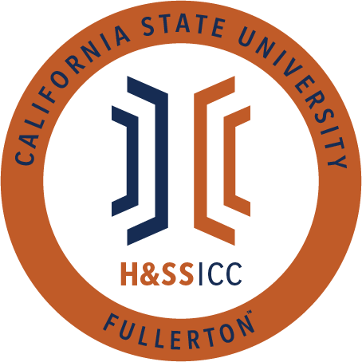

May 14, 2021 11:00 A.M. Zoom

Meeting called by:
Tonya Somesh, Chair
Type of meeting:
Regular
Attendees:
Council Representatives, Executive Officers, General Public
Agenda Topics:

- Call to Order / Roll Call
- Approval of Minutes
- Approval of Agenda
- Public Speakers
This is a time where members of the public may address the humanities and social sciences council on any item appearing on this agenda or matters impacting students.
5. Budget
    - 8074 – Contracts, Fees and Rentals: $11,008.19
    - 8077 – Travel: $17,875.00
6. Reports
- Chair – Tonya Somesh
- Vice-Chair / Treasurer – Bernard Perone
- Director of Administration – Savannah Arana
- Director of Public Relations – Jennifer López
- Social Justice Facilitator – Tonya Somesh
- Advisor – Dr. Connie Moreno Yamashiro, Assistant Dean
- Graduate Assistant – Shanice Watson
- ASI Liaisons – Erick Murillo and Maria Linares
7. HSS Week Committees (April 5th- April 9th, 2021)
8. Old Business
9. New Business
- Action: LSSA is requesting $250.00 from line item 8074. LSSA is requesting these funds to purchase five $50.00 VISA gift cards. These gift cards will be given out at their Study Hour event on May 18 from 12:00 to 1:00 PM via Zoom. Cards will be given out at random using www.wheelofnames.com
- Action: PAGSOCA is requesting $240.00 from line item 8074. PAGSOCA is requesting these funds to purchase six $40.00 Target gift cards. These gift cards will be given out at their Pictionary Night #3 event on May 21 from 7:00 to 8:00 PM via Zoom. Gift cards will be given to the winning team at the event.
- Action: PAGSOCA is requesting $240.00 from line item 8074. PAGSOCA is requesting these funds to purchase six $40.00 Target gift cards. These gift cards will be given out at their Thesis Writing Workshop #6 event on May 18 from 7:00 to 9:00 PM via Zoom. Gift cards will be given out through an opportunity drawing.
- Action: Geography Club is requesting $250.00 from line item 8074. Geography Club requests these funds to purchase one $100.00 gift card and two $75.00 gift cards for Map Shop. These gift cards will be given to first, second, and third place winners for their Map Competition event that will be voted upon from May 16 to 21 via Google Forms.
10.Next Week’s Agenda
- This is the final HSS ICC meeting of the semester, so clubs cannot add themselves to the agenda.
11.Announcements
12.Adjournment

