Welcome to Cal State Fullerton – Meet us virtually on April 18, 2020

All of us here in the History Department are excited to welcome you to Cal State Fullerton. We can’t wait to see you in our classrooms, talk to you in our offices, and show you all the ways in which history makes sense of the world, enriches your lives, and builds your careers.
Here at Cal State Fullerton, we help you think beyond your graduation and prepare you for meaningful professional lives afterwards. From archives, museums, national parks and schools to all levels of government, media, business, and law - our alumni work in almost 100 different careers.
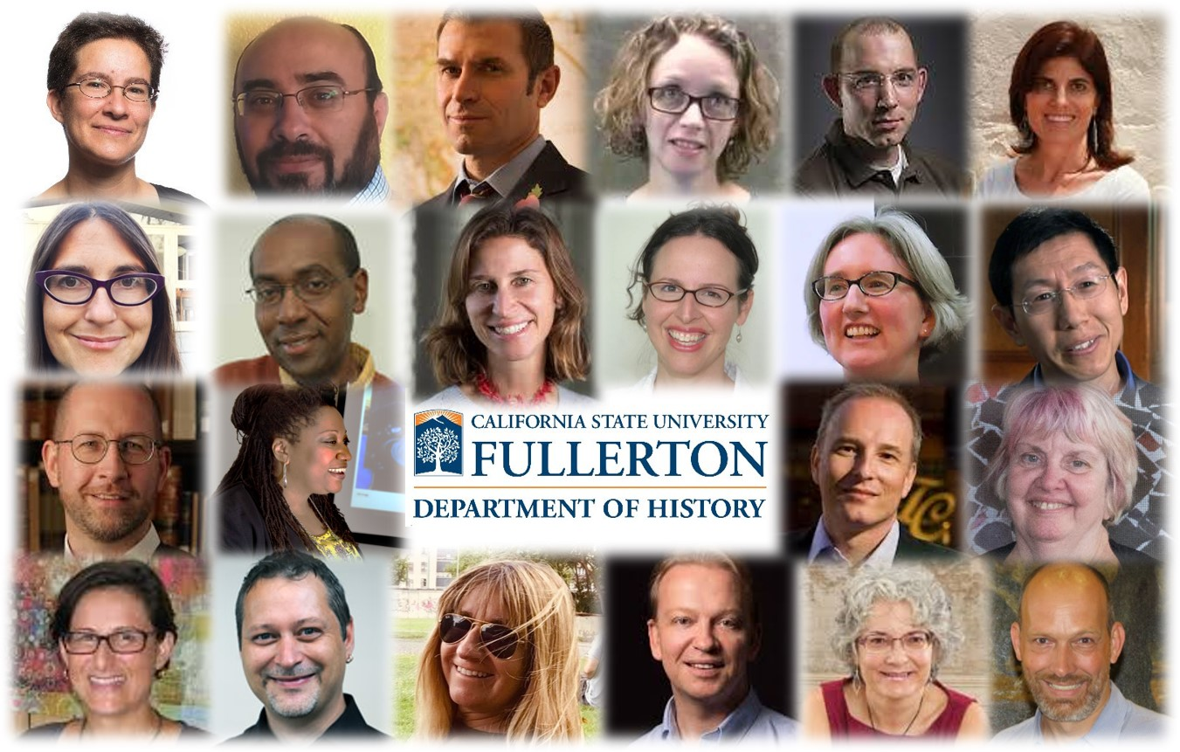
At Cal State Fullerton’s Center for Oral and Public History, you have the chance to learn historical fieldwork at one of the nation’s leading public history research centers. In addition, we currently place our students at over forty different internship locations. To find what you can do with a Titan History degree, follow this link:

https://spark.adobe.com/page/MPEdb/.
You can also learn more about your future history faculty, fellow students, and the department staff on our social media.
twitter.com/csuf_history
www.facebook.com/CSUFHistory
www.instagram.com/csuf_history

As a History major at CSUF, you will find support and help beyond the History Department.
In the college of Humanities and Social Sciences, the Student Success Team provides you with resources and academic advising. The student success team also provides you with important information on things like our study abroad and DC scholars programs, tips on ways to get involved in clubs and organizations, and so much more:
http://hss.fullerton.edu/student_success_team/index.aspx.
Here at Cal State Fullerton’s History Department, we care about your education, make sure you get lots of hands-on-experience, work in teams, and practice crucial skills for the future - all from accomplished faculty who have won numerous awards for their research and publications. We encourage you accepting our offer of admission as a History major. If we can do anything to help, please feel free to reach out to History Department Chair Jasamin Rostam-Kolayi at jrostam@fullerton.edu.
We’ll see you soon and hope you will join us for a welcome and introduction on April 18th in a virtual meeting. For details, please visit: http://hss.fullerton.edu/wtcsufd/

Best wishes,
Prof. Volker Janssen, Vice Chair
Prof. Jasamin Rostam-Kolayi, Chair

