CSUF College of Humanities & Social Sciences
Inter-Club Council Meeting
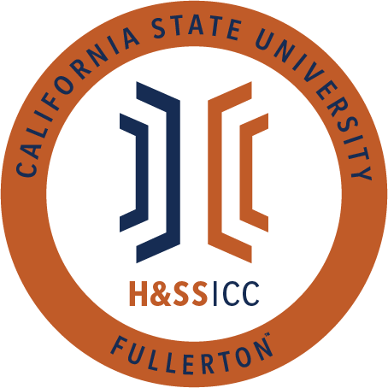

October 9, 2020 11:00 A.M.
Zoom

Meeting called by:
Halima Baba, Chair

Type of meeting:
Regular

Attendees:
Council Representatives, Executive Officers, General Public

Agenda Topics:

- Call to Order / Roll Call-11:00 AM
- Approval of Minutes
  - AAEE motions to approve the minutes and CJSA seconds
- Approval of Agenda
  - Dir. of Public Relations motions to amend the time and date of the agenda and AAEE seconds
  - Vice Chair/Treasurer motions to amends the budget for line item 8074 and CJSA seconds
- Public Speakers
This is a time where members of the public may address the humanities and social sciences council on any item appearing on this agenda or matters impacting students.
Time Certain 12:30PM – Viewpoint Neutrality
5. Budget
  - 8074 – Contracts, Fees and Rentals: $33,500.00
  - 8077 – Travel: $19,773.00
6. Reports
- Chair – Halima Baba
  - Nothing to report, so I will yield.
- Vice-Chair / Treasurer – Lila Marlene Rodriguez
  - The checklist for both 8074 and 8077 has been updated on the website. So please use these checklists when creating your proposal packet. New updates will be reflected in these documents. Use these documents and refrain from editing them. We want to maintain consistency for ASI.
  - Please make sure to include a checklist at the beginning of your proposal packet so you can ensure you have the needed documents.
  - Guidelines for the gift cards were finalized last week. There is currently no limit for the number of gift card events you can request for. So, please use the fund we have! No limit on gift cards should equal more motivation for making proposals. Lila is open to questions so, please email her about what you envision your event to be. Envision as in tell her what companies you want to request gift cards from. Lila will run her questions by Asha.
  - You need to submit both the gift card form and one of the checklist forms for gift cards. You will include # of students and other information.
  - If you want to request art supplies, you need to ask Lila to ask Asha and provide her with a list of stores. Gift cards will not cover shipping and fees.
  - Gift cards can buy a range of items like art supplies, but the gift card fund cannot cover any shipping. For example, you can give gift cards to students and have them go out and buy their art supplies but not send them art supplies.
  - We cannot do shipping because we want all the funds to go to students and not eaten up with shipping.
- Director of Administration – Savannah Arana
  - Nothing to report, so I will yield.
- Director of Public Relations – Jennifer López
  - Nothing to report, so I will yield.
- Social Justice Facilitator – Tonya Somesh
  - Nothing to report, so I will yield.
- Advisor – Dr. Connie Moreno Yamashiro, Assistant Dean
  - This is a very stressful time for students, and we understand. One resource for students is You@Fullerton it is a virtual wellness platform tailored towards individual student needs. https://you.fullerton.edu/
  - Another resource is CAPS (Counseling & Psychological Services). They are open and fully operating right now. If you feel like speaking to a professional will benefit you, these services are available to you. You have already prepaid with your student fees, so you should take advantage of this resource. They also offer workshops and support groups. www.fullerton.edu/caps
  - Please go out and vote! Not just for president but for local officials. Read beforehand about candidates and make informed decisions. Please create a plan and get out and vote! You have until October 19th to register. http://www.fullerton.edu/election/
  - The student success center is hosting a workshop on Wednesday. It will be a first-generation student panel.
- Graduate Assistant – Shanice Watson
  - The website will be updated with new information starting this week, so keep an eye out for that!
- ASI Liaisons – Erick Murillo and Maria Linares
  - Maria
    - Nicole Gillespie, the ASI Chief Campus Relations Officer, sent this message that she was in a meeting with provost Dr. Thomas. Dr. Thomas said she was writing a letter to the faculty about proctorio. Proctorio is a program some faculty members use during exams, which can scan your room, eye movement, and have other access to your computer while you take a test. Provost wants students to be a part of the letter and is asking Nicole to gather comments from the students. Please reach out to Maria if you're going to be a part of this letter. Many people don't like proctorio because there are concerns about security issues, as well as it increases anxiety. More information will be uploaded to the GroupMe.
    - The academic senate has campus-wide committees with various areas of focus and openings. So if you are interested in joining a committee, please look at the flier posted on GroupMe. Apply and let all your friends know! Student representation is vital to your orgs.
  - Erick
    - ASI scholarships will be closing today at 4 PM. Please let everyone know and make sure to apply before it is too late.
7. HSS Week Committees (April 5th- April 9th, 2021)
Nothing to report for this week
8. Old Business
9. New Business
AAEE motions to open line item A of new business and Philosophy Club seconds
- Club Presentations
- Abled Advocators
- Alpha Kappa Delta Sociology Club (AKD)
- American Studies Student Association (ASSA)
- Anthropology Students Association
10. Next Week’s Agenda
AKD-Sociology Club would like to be added to next week's agenda for line item 8077
ASA would like to be added to next week's agenda for line item 8077
UNA-CSUF would like to be added to next week's agenda for line item 8074
Rebound Scholars would like to be added to next week's agenda for line item 8077
PAGSOCA would like to be added to next week's agenda for line item 8077
Please turn in your proposal packet by Monday at 9 AM and send your email to the Chair, Vice Chair, and DOA
11. Announcements
- ASI scholarships are due today, and the deadline is precisely at 4 PM. Staff will not make an exception, and it shouldn't take that much time to fill it out.
- LASSA will be having a movie night tonight at 7 PM. The movie will be Coco, and there will be a discussion about Día de Muertos in Latin America. The link for zoom can be found on the GroupMe flier.
- AKD Sociology Club will be hosting an event on Tuesday, October 13th, from 4:15 to 5:15. The event is called "What can I do with a sociology degree?" and will have different sociology speakers talking about their profession and experiences. The flier will be posted on GroupMe.
- PDSA will have professor Vienna Sa as a guest speaker next week to discuss music therapy psychology on Wednesday, October 14th, from 4 to 5 PM. She is very informed and taught many courses before. So please come, and you can find the flier on the GroupMe.
- PDSA also be hosting a Q&A with Professor Perry from their last discussion workshop. The flier will be posted on GroupMe.
12. Adjournment-12:04 PM

