CSUF College of Humanities & Social Sciences Inter-Club Council Meeting
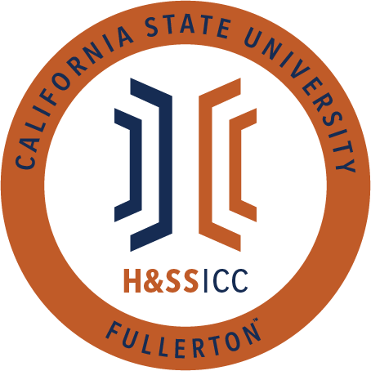

February 12, 2020 11:00 A.M. Zoom

Meeting called by:
Bernard Perone, Vice-Chair/Treasurer
Type of meeting:
Regular
Attendees:
Council Representatives, Executive Officers, General Public
Agenda Topics:

- Call to Order / Roll Call-11:05 AM
  - Geography Club is marked as absent
- Approval of Minutes
  - SIRE motions to approve the minutes and TESOL Club seconds
- Approval of Agenda
  - LSSA moves to be removed from the agenda and LSA seconds
  - Psi Chi moves to removed from the agenda and SIRE seconds
  - Phi Alpha Theta motions to approve the agenda and Psi Chi seconds
- Public Speakers
This is a time where members of the public may address the humanities and social sciences council on any item appearing on this agenda or matters impacting students.
Time Certain: 12:00-12:20pm with Dean Fontaine and Associate Dean Stern

5. Budget
    - 8074 – Contracts, Fees and Rentals: $31,985
    - 8077 – Travel: $19,181
6. Reports
- Chair – N/A
- Vice-Chair / Treasurer – Bernard Perone
  - When requesting line item 8074 (gift cards), gift cards with fees like Visa are not covered by ASI budgeting! Stick to store specific cards that have no fees (i.e., Target, Amazon, etc.) Having cards with fees only takes away from the students who need the money.
  - Monday at 10 AM is always the deadline for clubs who plan on proposing the following Friday. Nevertheless, next Monday, 2/15, is a holiday so please be mindful of the required documents and signatures.
  - We will not accept packets next Tuesday! This stands and was stated in the meeting.
- Director of Administration – Savannah Arana
  - Nothing to report but please rename yourself to your club names to make minute taking easier for me.
- Director of Public Relations – Jennifer López
  - Nothing to report, so I will yield
- Social Justice Facilitator – Tonya Somesh
  - I received submissions from the qualtrics and will be presenting very soon on new topics.
- Advisor – Dr. Connie Moreno Yamashiro, Assistant Dean
  - We need to fill the Chair position! We sent out the application this week, and it's due next Monday at noon! Please apply and share it with all your friends.
  - Financial aid deadlines are coming up very soon! Please apply before March 1st and make sure to get priority.
  - Career Center Workshop Request Form: If any club, organization, or faculty member would like to request a career exploration or professional preparation workshop from the Career Center, they are welcome to fill out this form https://www.fullerton.edu/career/faculty-staff/request-workshop.php
- Graduate Assistant – Shanice Watson
  - We are currently drafting up an invoice template for students to use, so it should be on the website either today or early next week.
- ASI Liaisons – Erick Murillo and Maria Linares
  - Maria Linares
    - Today is the "Angela Davis tried to warn us" event at 2 PM. All are invited, and the flier will be posted on GroupMe.
    - ASI direct from the board videos will be posted on GroupMe. These are great informative videos for students to learn more about ASI and the people in ASI.
    - Spring ASI 2021 scholarships will close on March 5th at 4 PM. The link will be shared in GroupMe.
  - Erick Murillo
    - The finance committee is looking at the budget again, so let him know if you want ASI to seek specific funding.
7. HSS Week Committees (April 5th- April 9th, 2021)
- Every club must host an event during HSS week or they will removed from the council
- HSS Week club event submission due by 11am on Feb. 26: http://fullerton.qualtrics.com/jfe/form/SV_6fXB0mfSw7gu8Mm. Event must be hosted during HSS Week April 5-9, 2021
8. Old Business
9. New Business
AKD motions to open line item A of new business and LSSA seconds
- Sociology Club is requesting $50.00 from line item 8077. These funds are being requested on behalf of David Ortuno, who will be attending and presenting at the Pacific Sociological Association's Conference from 3/17 to 3/21 via Zoom. Funds will be used to cover the registration fee.
  - 19 out of 20 approve/ Motion is passed
ASSA motions to open line item B of new business and TESOL Club seconds
- American Studies Student Association (ASSA) is requesting $150.00 from line item 8077. These funds are being requested on behalf of Katherine Morales, who, along with another student, Nicole Dean, will be attending and presenting at the virtual 2021 Popular Culture/ American Culture Conference on 2/22. Funds will be used towards registration fees.
  - 19 out of 20 approve/ Motion is passed
ASSA motions to open line item C of new business and LSA seconds
- American Studies Student Association (ASSA) is requesting $150.00 from line item 8077. These funds are being requested on behalf of Nicole Dean, who, along with another student, Katherine Morales, will be attending and presenting at the virtual 2021 Popular Culture/ American Culture Conference on 2/22. Funds will be used towards registration fees.
  - 19 out of 20 approve/ Motion is passed
Phi Alpha Theta motions to open line item D of new business and LSSA seconds
- Phi Alpha Theta is requesting $50.00 from line item 8074. Funds will be used to purchase five $10 Amazon e-gift cards. Gift cards will be given at PAT's Jackbox History Trivia Night on Friday, 2/19, via Zoom. This fun event is meant to be light-hearted and promote "historical thinking in a collegial setting."
  - 19 out of 20 approve/ Motion is passed
10. Next Week’s Agenda
- LSSA-8074
- ASA-8074
- TESOL Club-8074
- Psi Chi-8074
- Abled Advocators-8074
11. Announcements
- Sober Scholars will be hosting meetings on Wednesday at 2:30 PM. Judgment free zone for all students. The flier will be posted on GroupMe.
- HSA will be having their first official meeting today, and there will be a presentation on historical black figure 5-6:45 PM. The flier will be posted on GroupMe.
12. Adjournment-12:36 PM

