CSUF College of Humanities & Social Sciences Inter-Club Council Meeting
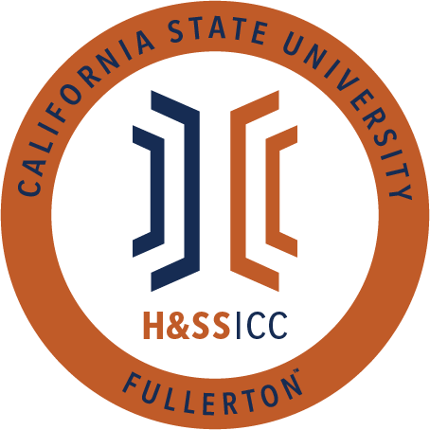

April 9, 2021 11:00 A.M. Zoom

Meeting called by:
Tonya Somesh, Chair
Type of meeting:
Regular
Attendees:
Council Representatives, Executive Officers, General Public
Agenda Topics:

- Call to Order / Roll Call
- Approval of Minutes
- Approval of Agenda
- Public Speakers
This is a time where members of the public may address the humanities and social sciences council on any item appearing on this agenda or matters impacting students.
5. Budget
    - 8074 – Contracts, Fees and Rentals: $21,433.16
    - 8077 – Travel: $18,019.00
6. Reports
- Chair – Tonya Somesh
- Vice-Chair / Treasurer – Bernard Perone
- Director of Administration – Savannah Arana
- Director of Public Relations – Jennifer López
- Social Justice Facilitator – N/A
- Advisor – Dr. Connie Moreno Yamashiro, Assistant Dean
- Graduate Assistant – Shanice Watson
- ASI Liaisons – Erick Murillo and Maria Linares
7. HSS Week Committees (April 5th- April 9th, 2021)
8. Old Business
9. New Business
- Action: Phi Alpha Theta is requesting $250.00 from line item 8074. Phi Alpha Theta is requesting these funds to purchase ten Grubhub Gift Cards priced at $25 each. These gift cards will be given to the first ten attendees who RSVP for the Conversations with Scholars virtual event on April 15, 2021, from 7 to 8:30 PM.
- Action: PAGSOCA is requesting $240.00 from line item 8074. PAGSOCA is requesting these funds to purchase twelve Target gift cards priced at $20 each. Gift cards will be given as a reward to winning teams at the virtual Pictionary Night event on April 19, 2021, from 7 to 8 PM.
- Action: PAGSOCA is requesting $250.00 from line item 8074. PAGSOCA is requesting these funds to purchase five Target gift cards priced at $50 each. Gift cards will be given to attendees of the virtual Thesis Writing Workshop on April 12, 2021, from 7 to 9 PM. Cards will be given away in an opportunity drawing.
- Action: AKD is requesting $3,000.00 from line item 8074. AKD will be hosting a virtual event called Sociology Week from April 14 to April 15, 2021, from 12 to 6 PM. This event's theme is "Racism in the 21st Century." and will feature a total of five guest speakers. All speakers will receive a $500.00 honorarium except for keynote speaker Dr. Jennifer Mueller, who will be receiving a $1,000.00 honorarium.
- Action: Psi Chi is requesting $250.00 from line item 8074. Psi Chi will be hosting a virtual Game Night event on April 5, 2021, from 5 to 6 PM. At this event, game winners will be allowed a choice of either a $25 Amazon or Starbucks gift card. There will be a total of five $25 Amazon gift cards and five $25 Starbucks gift cards.
- Action: Vote for Chair
- Action: Vote for Vice-Chair/ Treasurer
- Action: Vote for Director of Administration
- Savannah Arana Major: Anthropology Pronouns: she, her, hers
- Action: Vote for Director of Public Relations
- Nick Olivar Major: MS TESOL Pronouns: he, him, his
- Bhumi Patel Major: Sociology major Gerontology minor Pronouns: she, her, hers
- Penelope Antonio Major: Psychology Pronouns: she, her, hers
- Action: Vote for Social Justice Facilitator
- Jose Castillo Major: Psychology Pronouns: he, him, el
- Roqayah Hamdi Major: Political Science
- Leah K. Yagin Major: Sociology Pronouns: she, her, hers
- Gyu Jin Kim Major: Psychology Pronouns: she, her, hers
- Monique Garcia Major: History and Chicana/o Studies Pronouns: she, her, hers
10. Next Week’s Agenda
11.Announcements
12.Adjournment

