CSUF College of Humanities & Social Sciences
Inter-Club Council Meeting
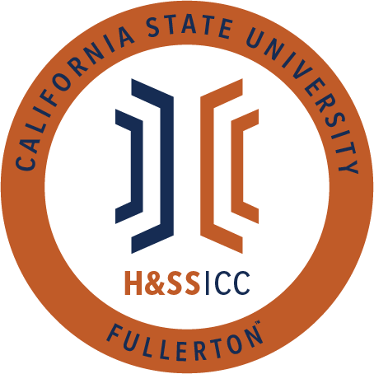

September 18th, 2020 11:00 A.M.
Zoom

Meeting called by:
Halima Baba, Chair

Type of meeting:
Regular

Attendees:
Council Representatives, Executive Officers, General Public

Agenda Topics:

- Call to Order / Roll Call 11:02 am
- Approval of Minutes
  - Minutes are approved
- Approval of Agenda
  - AAEE motions to approve agenda and AKD seconds
  - motion is approved/agenda is approved
- Public Speakers
This is a time where members of the public may address the humanities and social sciences council on any item appearing on this agenda or matters impacting students.
- Budget
- 8074 – Contracts, Fees and Rentals: $33,500
- 8077 – Travel: $20,000
- Reports
- Chair – Halima Baba
- Vice-Chair / Treasurer – Lila Marlene Rodriguez
  - Please remember that if you want to turn in a proposal, it needs to be in a virtual format. Proposals are submitted online only.
- Director of Administration – Savannah Arana
  - Nothing to report other than please follow Lila's previous request and send proposals completed in an online format.
- Director of Public Relations – Jennifer López
  - Nothing to report for today
- Social Justice Facilitator – N/A
- Advisor – Dr. Connie Moreno Yamashiro, Assistant Dean
  - The CSUF CAPS hosts a weekly Zoom group on Tuesdays from 1 PM to 2 PM for student parents. Please come and take advantage of this support network.
  - We are a funding council, so please take advantage of our funds and use them for your organization.
- Graduate Assistant – Shanice Watson
  - This upcoming week we will be updating the HSS ICC website, and we want to get the most recent social media accounts for current clubs. Please be on the lookout for our emails and be prepared to give us your club's most recent information.
- ASI Liaisons – Erick Murillo and Maria Linares
  - Erick
    - ASI is still trying to pass a resolution that will allow students to give more gift cards. There is currently a limit of 300 gift cards per event. Gift cards don't have to come from a specific store. There is a $10 minimum per card and a $250 maximum amount per card.
    - Updates for this resolution will be announced through the E-board.
  - Maria
    - ASI scholarships are still open, so please apply. Applications will be available through October 9th till 4 pm. Spread the word to your clubs, please.
    - No letter of recommendations are needed for ASI scholarships, so this should make applying easier for students
    - There is still an open position on the board of directors for the College of Health and Human Development.
- HSS Week Committees (April 5th- April 9th, 2021)
  - HSS week is a week organized by the HSS ICC where we can do events for the week. The events will include learning experiences as well as fun activities for students. This week's purpose is to inform students of the role of HSS and the clubs within our college.
  - Committees for HSS week will meet weekly and plan accordingly. All reports from the committee will be shared during this time.
  - HSS week takes place in the spring and will next year take place from April 5th to 9th. Nevertheless, we will start planning this semester, so please anticipate more information in the coming months.
- Old Business
- Organization Presentations
  - No new clubs have submitted their proposals since last week, so we will move onto new business.
- New Business
  - LSPA motions to open AAEE seconds motion
- Action: The Latinx Students Psychological Association (LSPA) is requesting $150.00 from line item 8074 for their event “Fab Grad Workshop,” which occurs on Tuesday, September 22, 2020, from 6:30 pm to 7:30 pm via a virtual zoom meeting. Funding will be used for guest speaker honorarium.
  - This event will be open to all students, and the zoom link can be found on the flier in the GroupMe chat.
  - Based on a roll call vote, 22/23 approve. The motion is passed.
- Discussion: Review the Resolution: Additional Guidelines for Funding Provided to Students and Student Groups
  - AKD-Sociology Club motions to open this discussion, and Phi Alpha Theta seconds that motion.
  - ASI will be resolving the issues related to gift cards this upcoming Tuesday. At the moment, there is a $250 amount per gift card limit.
  - Some students are recommending lowering the minimum to 20 dollars per gift card. By raising it to $20, students will hopefully cover more of the cost and fees of buying food/items.
  - The amount of gift cards will be determined this Tuesday by ASI. Afterwhich the E-board will inform the ICC of all the new details.
  - Some students suggest lowering the minimum gift card amount to 5 dollars. This will help bigger clubs give out more gift cards. Furthermore, raising the maximum expense may be a good idea to consider for students.
  - PDSA thinks a lower amount is better for gift cards since they have a lot of students.
- Discussion: Social Justice Facilitator Nominations
  - Rebound Scholars motions to open discussion and CJSA seconds
  - If anyone from the council or the public is interested in this position, please reach out to members of the e-board. Applications will be submitted online, and the e-board will review it.
- Next Week’s Agenda
  - ASSA would like to be added to next week's agenda where they will make a proposal from line item 877 (Travel)
  - AAEE would like to review the bylaws next week. Gaby of AAEE wants to review the bylaws for newer council members. She is hoping to review the most basic and important parts of the bylaws next week. Halima will make sure to send out the bylaws before the next meeting.
  - Aled Advocators would like to be added to next week's agenda where they will make a proposal from line item 8074 (Contracts, Fees, and Rentals
- Announcements
  - LASSA will be a movie night today (9/18) at 7 PM via Zoom link can be found on flier which is available on their Instagram. Next week (9/24) LASSA and AAEE will be hosting a virtual workshop that will talk about the importance of indigenous communities. The flyer for this event can be found on the GroupMe chat.
  - The next ASI mobile food pantry will take place on October 2nd. It is a contactless drive up and will take place in Lot R from 8 AM to 1 PM. There is a walk-up option for students without vehicles.
  - ASI Liaison Erick has been able to bring up the idea of an HSS forum to Dean Fontaine and she absolutely loves it! Furthermore, Dean Fontaine says there are exciting things on the horizon for students so be on the lookout.
  - Lastly, the Titan Recreation Center will be doing online workout tutorials and videos so please inform students of this fun and healthy opportunity.
- Adjournment
  - 12:44 PM ending

