Culminating Experience (3 units required)
TESOL 596 TESOL Practicum (3)
The practicum is taken at the end of the program. Prerequisites are TESOL 500, 509, 510 and 527. The core and language pedagogy courses must be completed with an average grade of “B minus” (2.7) or better in order for students to enroll in the practicum.

Start a Career Teaching English in the U.S. or Abroad
TESOL Master of Science in Education
Teaching English to Speakers of Other Languages

Comprehensive Examination
After completing all Master’s degree coursework relating to core and selected pedagogy, students must take a written exam of all the courses taken in the program. For further information, contact the TESOL graduate· program advisor.

What is the difference between the Graduate TESOL Certificate and the Master’s Degree in TESOL?
The Graduate Certificate is intended for students who are earning (or already have) a master’s degree in related fields such as linguistics, English, composition and rhetoric, etc. CSUF Master’s Degree in TESOL students automatically receive the Graduate Certificate once they complete its requirements. The graduate certificate differs from the master’s degree in terms of both prerequisites and graduation requirements: (1) Prerequisites for the Graduate TESOL Certificate do not include ENGL 300 (or equivalent) or LING 406. (2) The Graduate TESOL Certificate only requires two electives, does not require TESL 560 or 595 (although they may be taken as electives), and does not include the comprehensive examination.

Are scholarships available?
A small number of non-resident tuition waivers are available for students with superior academic records or exceptional professional promise. The waivers allow non-residents (including international students) to pay in-state rates for tuition and fees. Applicants must apply for these waivers by submitting letters of request with transcripts, three letters of recommenda- tion, and TOEFL score reports (for non-native English-speaking applicants who completed their bachelor’s degrees outside

Enhance Opportunities

Why should I study TESOL?

Apply Knowledge

Obtain Professional Training

the U.S.) to the TESOL Coordinator no later than April 15 or October 15 preceding each spring semester.

What are some special features and programs of the degree plan?
Students may also apply to the American Language Program (ALP), the English Writing Center, and Graduate Programs for part-time work. Many students also find off-campus teaching jobs prior to graduation. The program also has a collaborative exchange agreement with the Universidad Federal de Minas Gerais (UFMG) in Belo Horizonte, Brazil, where students may complete coursework towards their degrees and sometimes work. The use of technology is an integral part of the program.

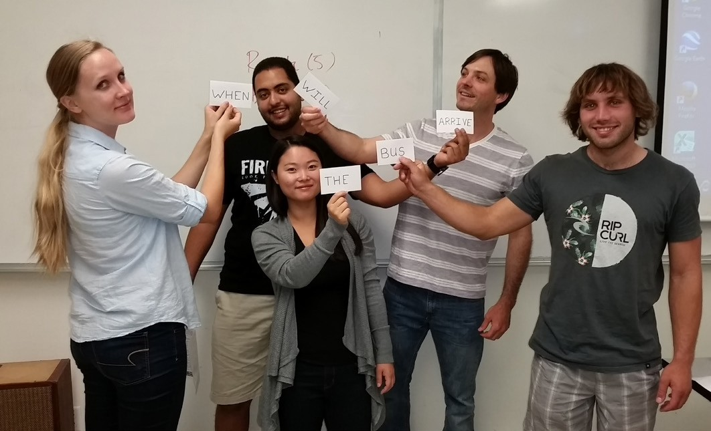
How can I get involved?
The TESOL Club invites all TESOL students to participate in club activities that may include speakers, service-learning
workshops, conferences, holiday celebrations, and recreational activities. Students have also collaborated with faculty members on classroom and school-based research projects.

Who advises me?
An assigned TESOL advisor provides academic and career ad- visement. Advisement takes place during the instructor’s office hours. All students must meet with the advisor within the first semester of graduate course work to develop a study plan.
For further information please visit our website at: hss.fullerton.edu/mll. You may also contact the TESOL Coordinator in the Department of Modern Languages and Literatures, California State University, Fullerton, P.O. Box 6846, Fullerton, California 92834-6846, or call (714) 278-3534.
Enthusiasm for language, desire to meet people from all over the globe, and love of teaching are a few of the many reasons to select the Master of Science in Education with a concentration in Teaching English to Speakers of Other Languages (TESOL), which is offered by the Department of Modern Languages and Literatures. This program is the largest public university master’s program in TESOL in Orange County and is NCATE-approved. It is also a multi-disciplinary program involving study in the fields of English, linguistics, education, anthropology, American studies, speech communication, and psychology. Courses are conveniently offered after 4 p.m. on weekdays. Our faculty members have expertise in teaching English in the U.S. and abroad in public school, adult education, intensive English program, community college and university settings.

What types of career opportunities are available?

Graduates may go on for doctoral work; however, the majority of graduates work as instructors in adult and community college English as a Second Language (ESL) programs in Orange, Los Angeles and San Bernardino counties. Some have been hired as resource specialists and program coordinators while others have taught or done teacher training abroad.
The California State Department of Education has recently approved a new ESL credential at the secondary level (World Language: ELD). The content of the M.S. TESOL program will assist students in passing the ELD CSET examination, which covers the content of the new subject matter program required for the new credential. It also provides background infor- mation that will facilitate passing the California Teacher of English Learners (CTEL) examination and obtaining the Adult Teaching Credential.

http://hss.fullerton.edu/mll/academics/tesol/ms_tesol.asp

What is required for admission to the master’s program?
-

Teaching English to Speakers of Other Languages (TESOL). Applications may be completed online at www.calstate.edu/ apply?

What are the requirements for the master’s degree in TESOL?
The minimum university and departmental requirements include: a baccalaureate degree from an accredited institution, a

Language Pedagogy (3 units required)
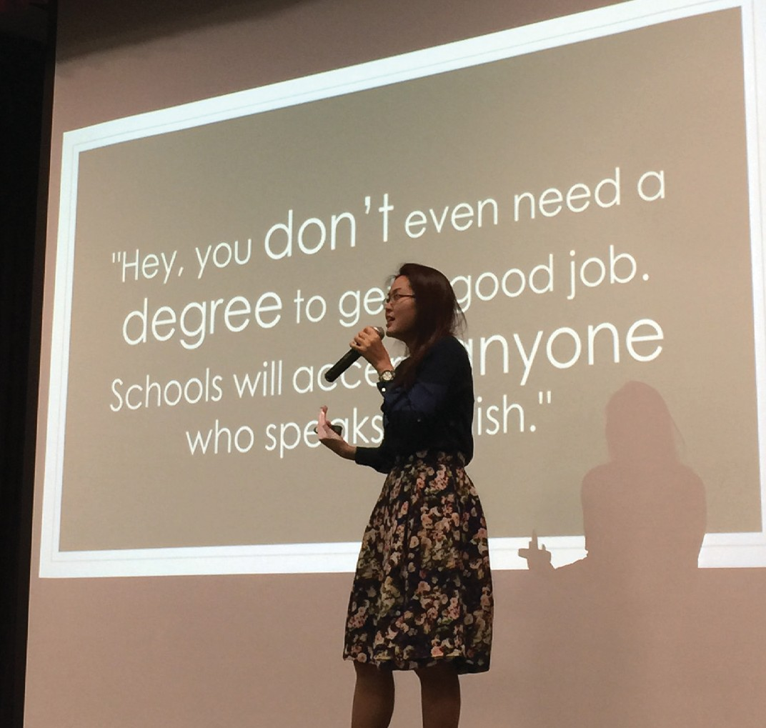
*TESOL 515 Pedagogical Grammar in TESOL (3 units)
OR *TESOL 520 Teaching Pronunciation and Oral Discourse in TESOL (3 units)
OR TESOL 525 Teaching Vocabulary in the ESL/EFL Classroom (3 units)
*In at least one of these courses, each student must complete 20 hours of service-learning at one of the sites approved by the TESOL Program.

grade point average of at least 2.7 in the last 60 semester units attempted, a 3.0 grade point average in the major and being

- Two years of one foreign language, or one year each of two different foreign languages or the equivalent with an average
3.0 grade point average. The requirement will normally be waived for students from foreign countries who have studied TESOL 301 or
TESOL 315
- English 303 with a grade of “B minus” (2.7) or better
- One of the following: American Studies 301, 345; Anthropology 360, Anthropology/ Linguistics 300; Comparative Literature 325; English 300, 305, 323T; Human Communication 320 or an equivalent course with a “B minus” (2. 7) or better
- Linguistics 406 with a grade of “B minus” (2. 7) or better

completed their bachelors degree in a language other than English must demonstrate (1) a minimum iBT score of 89, or a Paper-Based TOEFL score of 573, or a minimum IELTS score of 7.0 overall, or a Pearson Test of English (PTE) Academic score of 65 and (2) a minimum score of 26 on the iBT speaking section or 7.0 on the IELTS speaking section, or a passing score on the TESOL Program’s in-house interview test (for conditional admission, students may obtain a 23 on the iBT speaking section or a 6.5 on the IELTS speaking section). In addition, admission to the master’s program in TESOL requires completion of all course prerequisites and the development of an approved study plan, in consultation with an advisor, prior to completion of nine units applicable to the study plan. Please consult the university catalog for more details.

What courses are required to complete the degree?

The study plan includes 33 units of committee-approved course work: 18 units of core courses, three units of language pedagogy, nine units of electives, and three units of the practicum, which includes a comprehensive exam. All M.S. TESOL students must obtain a minimum of a “B minus” (2.7) grade in each core course and a “B minus” average in all language pedagogy and elective courses combined.

Core Courses (18 units required)
TESOL 500 Fundamentals in TESOL (3 units)
*TESOL 509 Advanced Principles of TESOL (Listening/Speaking Focus) (3 units)
*TESOL 510 Advanced Principles of TESOL (Reading/Writing Focus) (3 units) TESOL 527 Second Language Acquisition (3 units)
TESOL 560 Second Language Assessment (3 units)
TESOL 595 Curriculum and Program Design for TESOL (3 units)

Electives (9 units required)
Students choose nine units from the list of courses provided be- low. Other 400 and 500-level courses may also be selected with advisor approval. Complete descriptions of courses can be found in the departmental course listings in the University Catalog.

Culture and Literature
Anthropology 412, 470
Chicana/a Studies 450, 480
Human Communication 420, 422, 522
Reading 560

Language and Linguistics
Anthropology 416
French/German/Japanese/Spanish 466
Japanese/Spanish 468
Linguistics 412, 417, 442, 505, 507, 508

Testing, Technology and Research
Anthropology 401
Education Elementary 511, 515, 518A, 518B, 519, 522, 551, 590
Education Secondary 504,524,535
Linguistics 501

Professional Education
Elementary Education
Elementary Education 434, 500,521, 528,529, 530,531,536,
541,542,552,553
Reading 508
Secondary Education
Education Secondary 410, 442, 522, 536, 540, 550

TESOL 511, 545
400- and 500-level advisor-approved American Studies courses
400- and 500-level advisor-approved English or American literature courses

Reading 514
Spanish 467
TESOL 515, 520 or 525 if not taken as language pedagogy courses

Psychology 461, 465
Reading 516, 520
TESOL 530, 532

Adult/College Education
English 402, 402S, 590
Reading 507, 581

