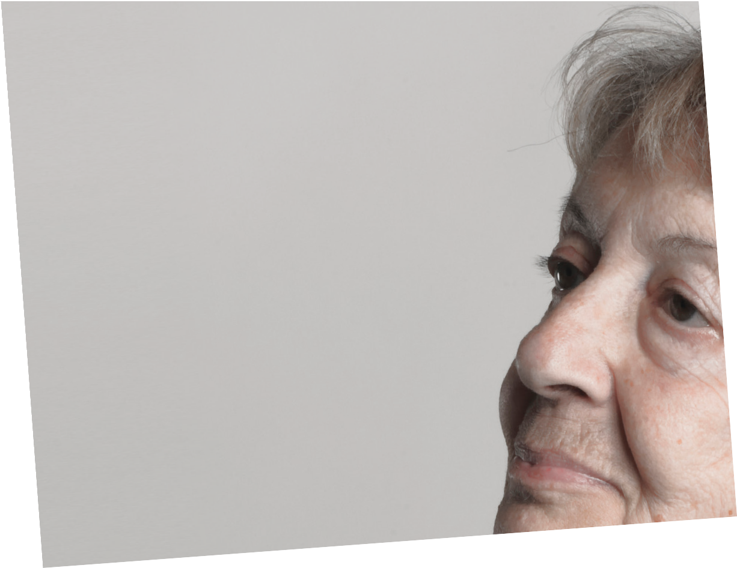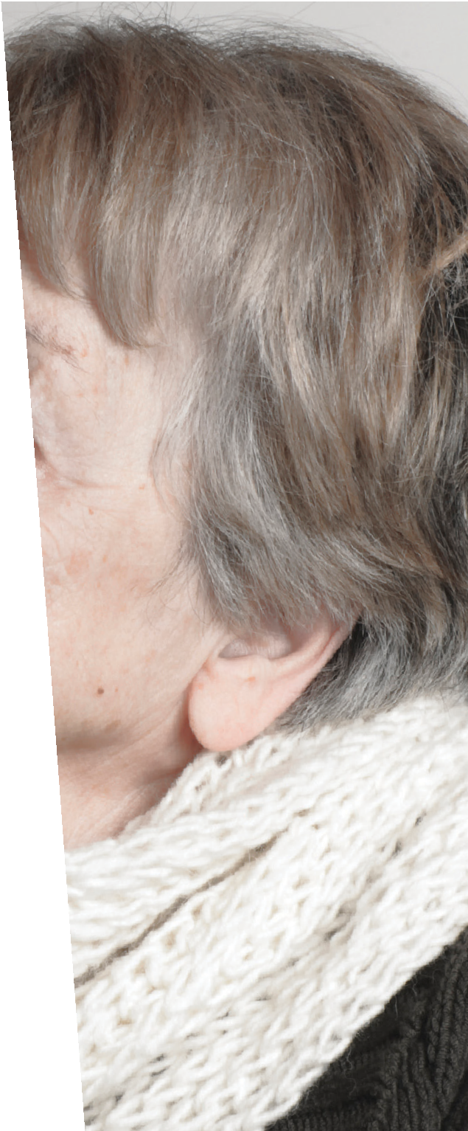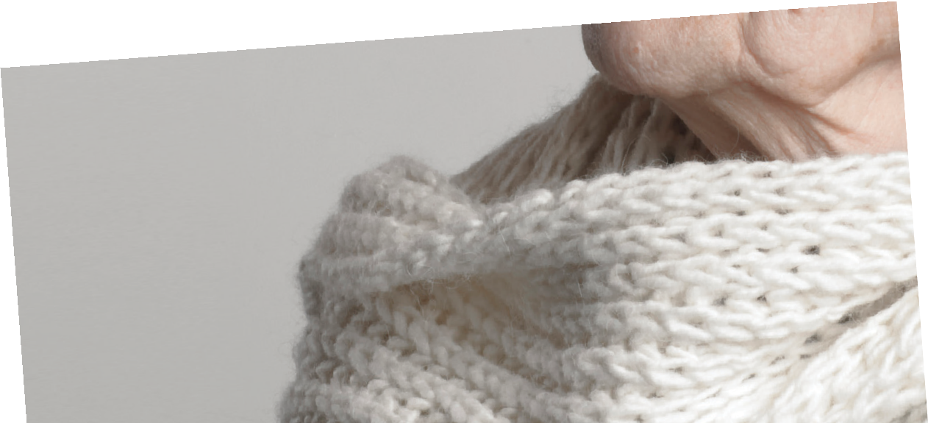

OLDER ADULTS’ HEALTH
AND AGE-RELATED CHANGES
Reality Versus Myth

THE UNITED STATES—AND THE
- Nearly 10% of older adults live in poverty. Older women are almost twice as likely to be living in poverty as older men. Racially and ethnically diverse older adults are more likely to be poor than White older adults.
- Almost 2 million older people live in households with a grandchild present. Almost half a million of these grandparents who are over the age of 65 have primary responsibility for their grandchildren.
TODAY’S LIFE EXPECTANCY
Men: 84.3 years
Women: 86.6 years
alone increases with advancing age. Among women aged 75 and over, almost half live alone.
- The percentage of older persons who have completed high school has risen from 28% to 84% since 1970.
A SNAPSHOT OF TODAY’S OLDER ADULTS
- One out of every four 65-year-olds today will live past age 90, and one out of 10 will live past age 95.
- The number of Americans over age 85 is increasing faster than for any other age group.
- Women continue to outnumber men at older ages. Among people over 100 years old, 85% are women—but the gap between men and women is narrowing.
- The proportion of older adults living
WORLD—ARE AGING. The number of Americans aged 65 and older is projected to double from 46 million to more than 98 million by 2060.
It will be the first time in history that the number of older adults outnumbers children under age 5.
In addition, older adults will live
longer than ever before: One out of every four 65-year-olds today will live past age 90. This demographic shift has moved the focus of re- searchers, health care providers, and policymakers from how to extend
the lifespan to ways to improve the quality of our later years.
Staying healthy, active, and pro- ductive are admirable goals for our nation’s older adults. However, soci- ety’s view of “old age” has not always kept up with the reality of being old in America. Many current beliefs about aging were based on infor- mation that is no longer valid given recent scientiﬁc advances.

To provide information and per- spective about today’s older adults, this brochure provides facts and discusses myths related to aging.

NOT ALL OLDER ADULTS ARE ALIKE
Many assume that older adults
are all alike. However, as this age group includes 5 decades of in- dividuals, the differences among older adults are great—actually greater than those seen in other age groups.

1.75–4 MILLION
Estimated number of older adults in U.S. who are lesbian, gay, bisexual, or transgender— a number that is expected to double in the next 2 decades.

- Whereas today, most older adults are White, a dramatic transformation will occur within the next 2 decades, resulting in a population that is more culturally diverse.
- Between 2010 and 2030, the
White population 65+ is projected to increase by 59%, compared with 160% for older minorities. Older Latinos will account for the largest increase: In 2030, they will constitute 22% of the older population, compared to 8%
of today’s older adults.
The population of older immigrants in the U.S. has increased by 70% in
the last 20 years, from 2.7 million to
4.6 million.

COGNITIVE AND MENTAL HEALTH
- For most older adults, age-associ- ated changes in cognition (thinking) are mild and do not significantly interfere with daily functioning.
- Older adults are capable of learning new skills even late in life, though learning may take longer than for younger adults.
- Short-term memory shows noticeable changes with age, but long-term memory declines less with age.
- Some changes in cognition are normal with age, such as slower reaction times and reduced prob- lem-solving abilities. The speed with which information is encoded, stored, and retrieved also slows as we age. However, many older adults outperform their younger counter- parts on intelligence tests that draw on accumulated knowledge and experience.
- Wisdom and creativity often continue to the very end of life.
- Personality traits remain relatively stable over time. For example, peo- ple who were outgoing during young adulthood are likely to be outgoing in later life.
- Most older adults report good mental health and have fewer mental health problems than other age groups. However, one in four older adults experiences a mental health problem such as
depression, anxiety, schizophrenia, or dementia.
- The suicide rate for men over 85 is higher than that of any other age group.
- The number of older adults
with substance abuse problems is expected to double to five million by 2020.
- Dementia (including Alzheimer’s disease, the most common type of dementia) is not a normal part of aging. Approximately 5% of individ- uals between 71 and 79, and 37%
of the population above age 90, are aﬀected.
- As they age, people are generally more satisfied with their lives and more optimistic about growing older.

PHYSICAL HEALTH
A number of physical changes and health issues are more common as we age. However, just as all older adults are not the same, their health status also varies. Many are active and healthy, whereas others are frail, with multiple health conditions.
- Approximately 92% of older adults have at least one chronic condition, and 77% have two or more.
- Four chronic conditions—heart dis- ease, cancer, stroke, and diabetes— cause almost two thirds of all deaths among individuals 65 and older each year.
- People 55 and older account
for over a quarter of all Americans diagnosed with HIV, and this number is increasing.
- Hearing impairment among older adults is often mild or moderate, yet it is widespread; almost 25% of

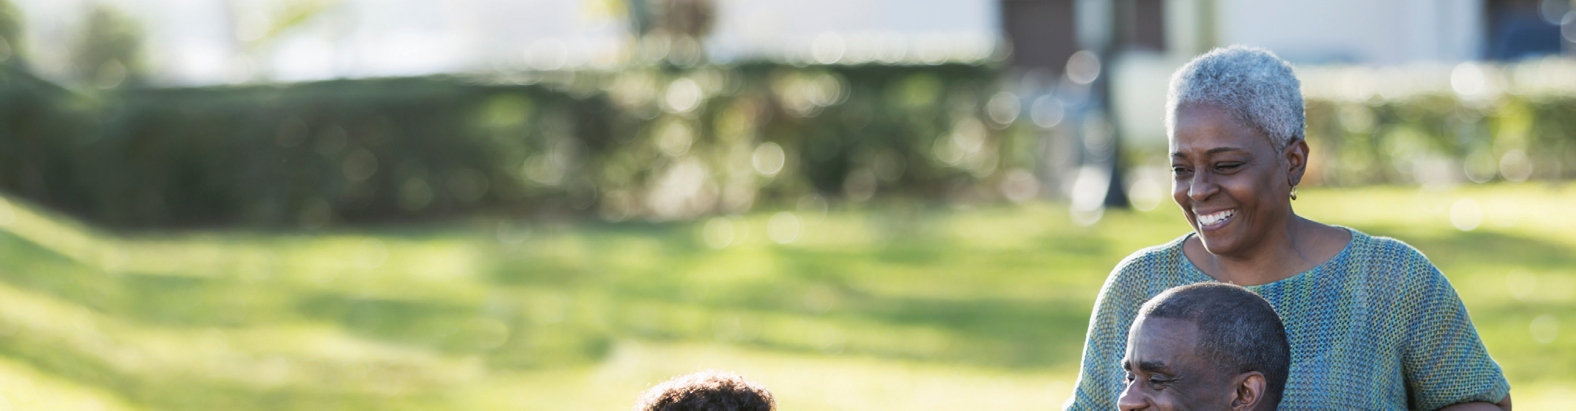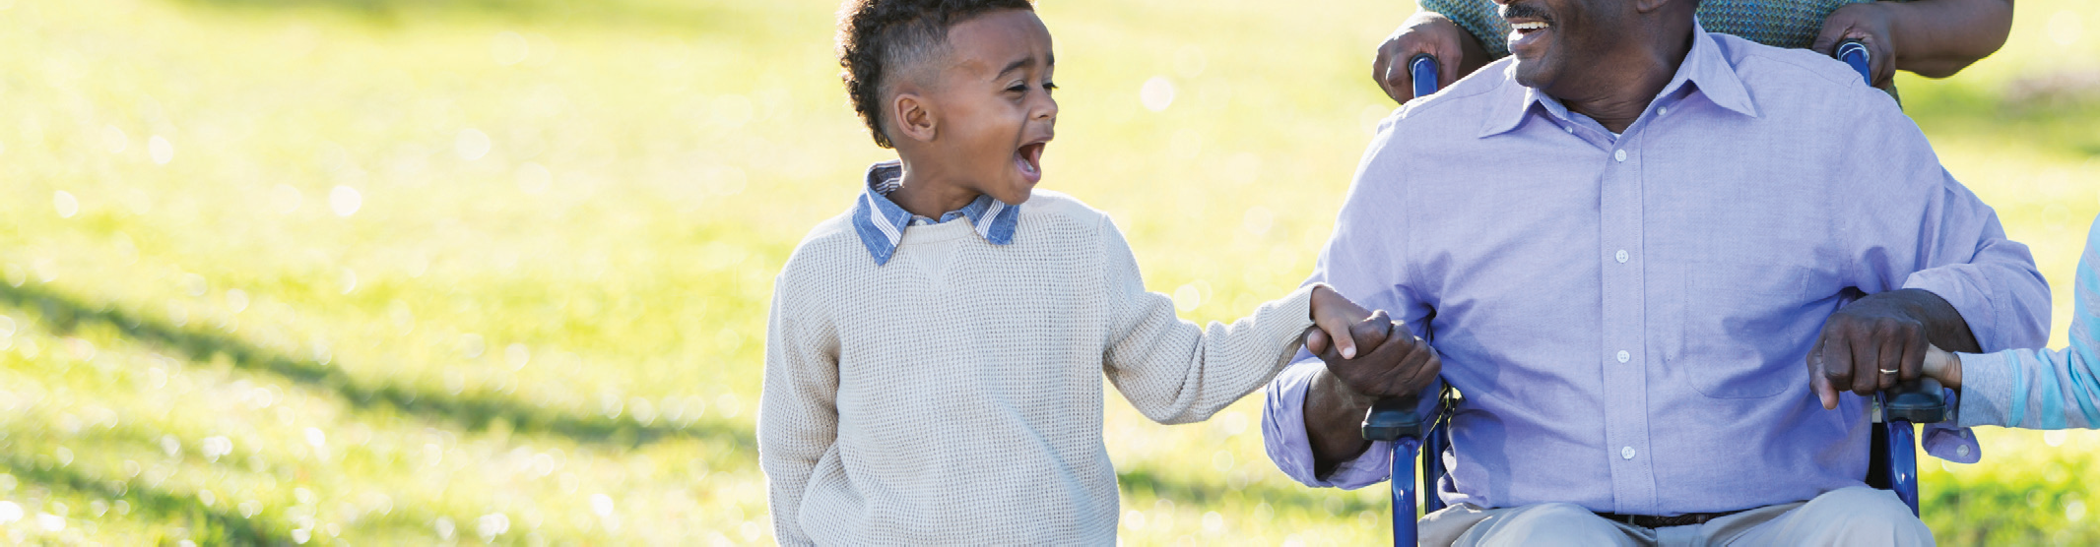

WHAT’S IMPORTANT TO REMEMBER. . .
Although many people over age 65 begin to experience some physical and cognitive changes, they learn to live with them and lead happy
and productive lives.
adults aged 65–74 and 50% aged 75 and older have hearing impairment that is often isolating.
  - Visual changes among aging adults result in such problems as slower reading speed and difficulty reading small print and in dim light, as well as difficulty driving at night.
  - The proportion of older adults need- ing assistance with everyday activities increases with age. Fewer than one fifth of older adults between ages 65 and 74 need assistance with activi- ties of daily living, such as bathing or eating. This increases to 40% of men and 53% of women over 85 who need such assistance.
  - Older ethnic and racial minorities have a higher prevalence of obesity, diabetes, and hypertension, as well as an earlier onset of chronic illness, than White older adults. Some of the factors contributing to this disparity are poverty, segregated communi- ties with fewer health-promoting

resources, poor education, unem- ployment, discrimination, and less access to quality health care.
- In spite of these mental and physi- cal health issues, two thirds of older adults who are not living in long-term care settings report their health to be good, very good, or excellent com- pared to others their age.

REALITY OR MYTH: WHICH IS IT?
People are often classified by age group and not by individual charac- teristics. This categorization often re- sults in inaccurate stereotypes about aging and older adults. The following statements reflect either the reality or a myth about older Americans.

Most older Americans live in nursing homes
MYTH. Only about 5% of older Americans live in nursing homes at any given time. However, the per- centage increases with age, ranging from 1.1% for persons 65–74 years to

3.5% for persons 75–84 years and
13.2% for persons 85+.

Most older adults stay socially engaged and productive
REALITY. Many older adults continue to work, volunteer, and act as caregiv- ers to other family members. Having regular positive interactions with family and friends and being involved in several diﬀerent social networks can help older adults be healthi- er—both physically and emotionally. Conversely, loneliness has a negative physical and emotional impact.

Older adults have little to no interest in sex or intimacy
MYTH. Although frequency of sexual activity may decline in older adult- hood, many older adults continue
to enjoy a physically and emotionally fulfilling sex life. Benefits of sexual activity include better sleep, less stress, more positive mood,
and increased marital satisfaction.

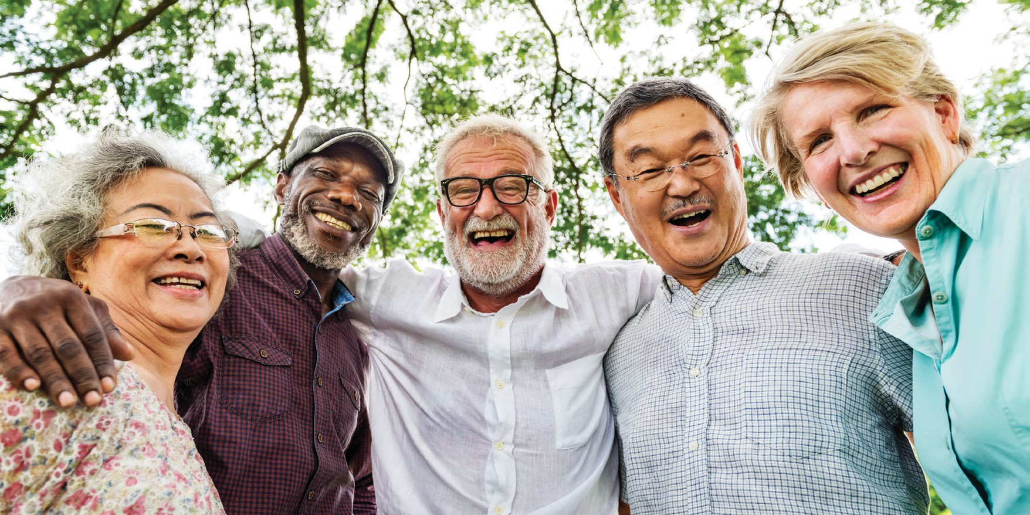Like younger adults, older adults who are in good health—and have a willing partner—are more likely to engage in sexual activity.

MAINTAIN TIES WITH FRIENDS AND FAMILY
to maximize your social support system, and as you experience age-related losses, seek their support to help you cope with those losses.

Individuals can learn new skills even in late life
REALITY. Older adults can learn skills in late life, although learning some skills may take longer than in younger adults. The adage “you can’t teach an old dog new tricks” is the myth.

There is nothing that can be done to reduce one’s risk of Alzheimer’s’ disease
MYTH. Physical and mental inac- tivity, smoking, obesity, diabetes, hypertension, and depression are all associated with an increased risk for the development of Alzheimer’s disease. Each of these factors can be modified. Keeping mentally and physically active can help preserve cognitive skills, reduce the risk of Alzheimer’s disease, and maintain overall health.

WHAT CAN YOU DO TO MAKE AGING WELL A REALITY?
Older adults who rate their health as good are twice as satisfied with life as older adults who rate their health as poor. Increase your chances of
aging well by taking some of the following steps:
- Exercise. Even a moderate
amount each day can help one stay active, independent, and maintain positive mood. It can make even the frailest older person stronger and more fit.
- Continue to maintain a healthy life- style and make adjustments
for any changes in your function (e.g., hearing, vision, flexibility, or strength).
- Continue to engage in routine pre- ventive health behaviors
(e.g., get immunizations for flu and pneumonia).
- Advocate for yourself and your fam- ily in health care settings or bring a knowledgeable representative with you. Do not be afraid to ask ques- tions or get a second opinion.
- If you feel anxious, depressed, or are using alcohol or drugs to manage your mood, seek assistance. Un- treated mental health problems are associated with poor physical health outcomes, including increased disability and illness, as well as de- creased quality of life
- Be an interested person. Remain aware of new developments in the
arts, sciences, politics, and other areas of cultural and social interest.
  - Be an interesting person.
Engage in something that matters to you and that you care passionate- ly about.

CONCLUSION
Armed with the facts about the myths and realities of aging, indi- viduals, families, and our society are better able to view older adults as resources and to provide appropriate support for those in need of assistance.

For more information, visit the APA’s Office on Aging website: www.apa.org/pi/aging

Office on Aging
American Psychological Association 750 First Street, NE
Washington, DC 20002-4242
Phone: (202) 336-6135
Fax: (202) 336-6040
Email: publicinterest@apa.org

This is an update of the 1998 brochure developed as an initiative of then APA President Norman Abeles, PhD.
© 2017 American Psychological Association

