Aging Studies

What is Gerontology?

We don’t study maps

and we don’t study dirt

but we do study older adults
Every job in any field will require it

Aging experts are referred to as Gerontologists

U.S. Bureau of Statistics Projects a
35% Increase in Aging-Related Jobs

Now Future

Why do we study older adults?

We do it to improve well-being!

Food Security

Housing

Social Networks

Technology
Health
Well Being
Transportation

Why this matters to you?

Psychologists
Gero-psychologists assess mental functioning, depression and other problems, and
play a significant role in improving the well being of older adults. In fact, 70% of practicing
psychologists provide some counseling service to older adults.
-American Pyschological Association
Marketers
Most marketing companies target the younger population, but for the first time in American history those over the age of 65 out-number the
youth. As noted by Scott Collins, “marketers must adapt and evolve in order to capitalize on this change.”
Knowledge of aging will increase student opportunities for future marketing-related careers.
-Evolution of the Aging Market

Engineers

Gerontechnologists aim at helping older adults maintain indepedence by developing prosthetics
or adapting environments to support activities of daily living and caregiving
networks through designed communication.
-International Society for Gerontechnology

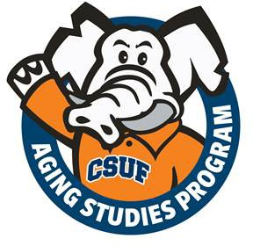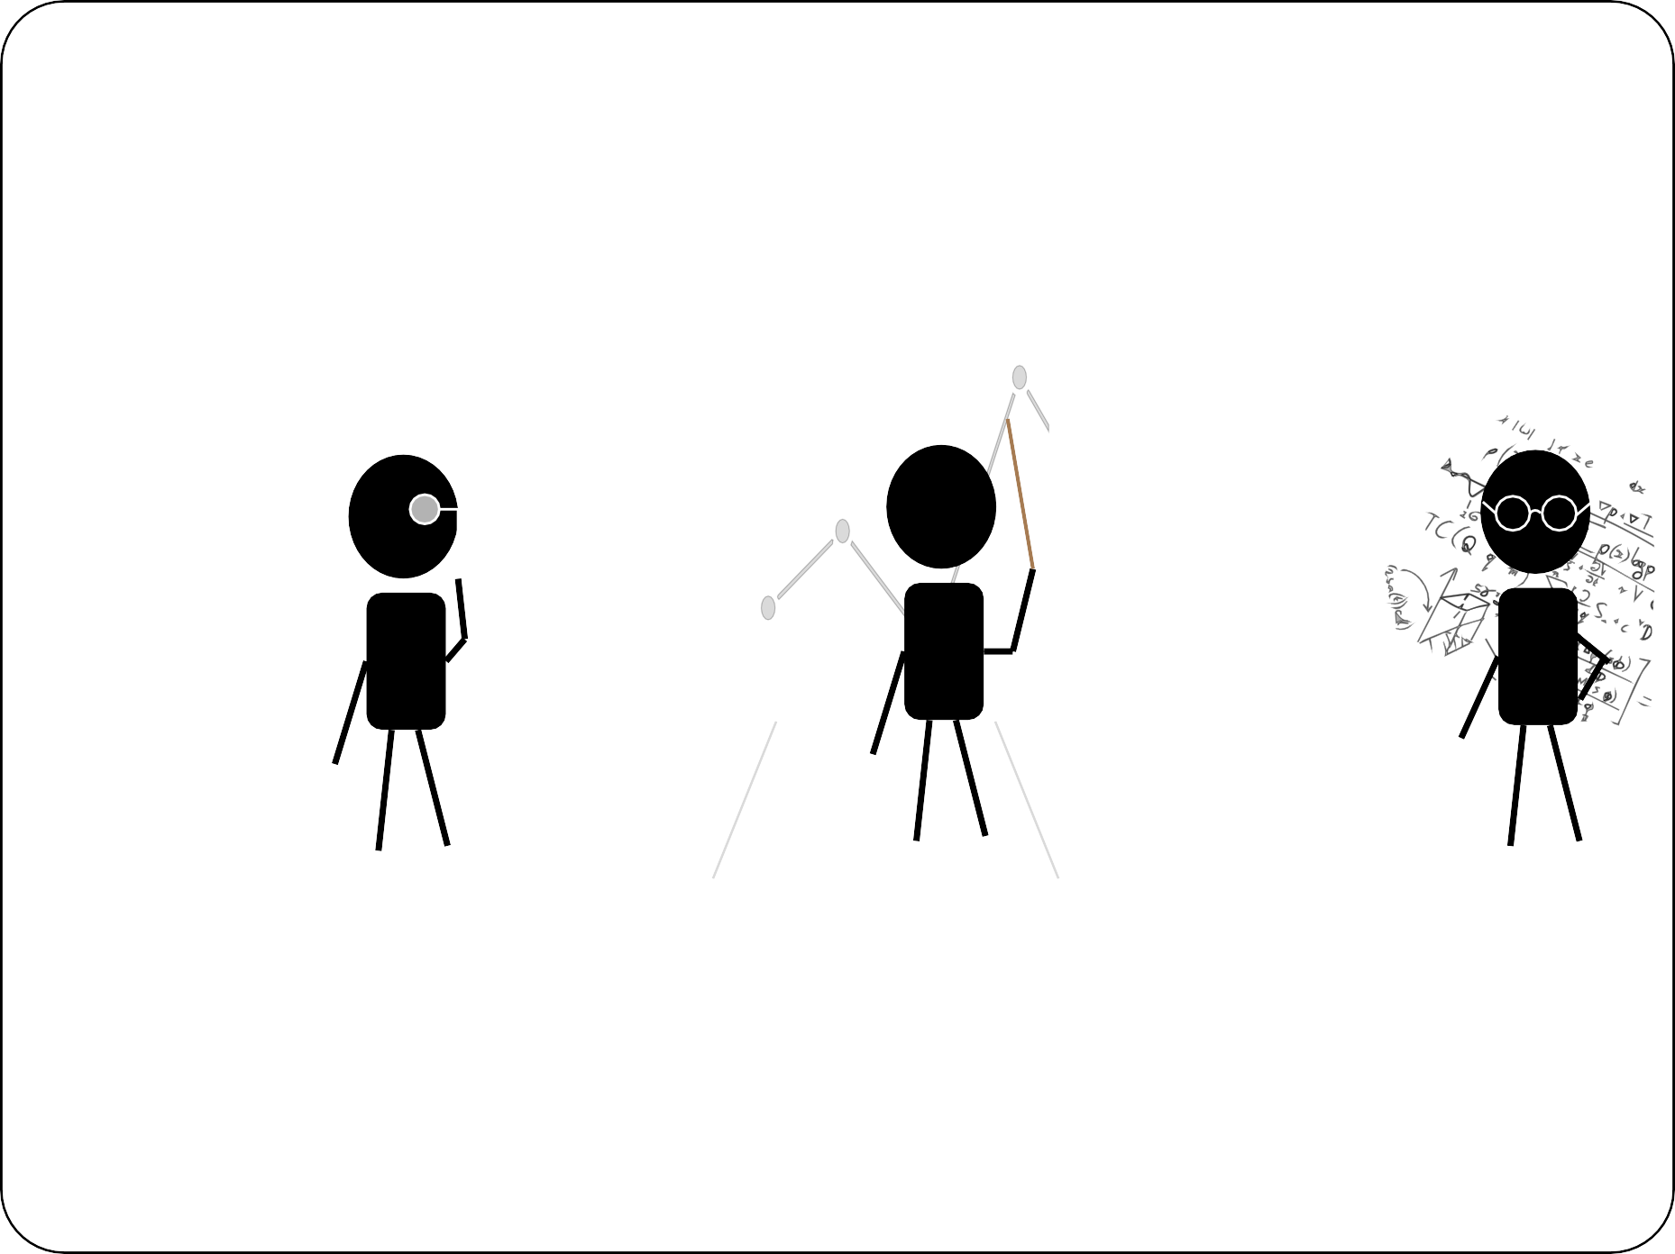
For more information please visit hss.fullerton.edu/agingstudies/ Or stop by the Aging Studies Academic Program Office in HSS 424

