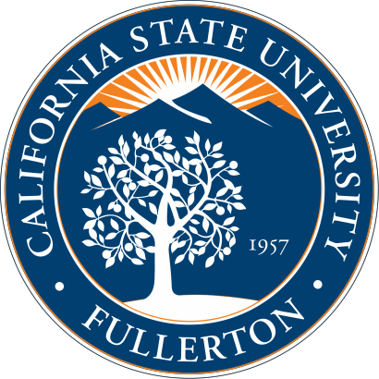
- Gerontology is the study of aging from a multi-disciplinary perspective, including health science, psychology, business, economics, medicine, sociology, and more.

- The older adult population is increasing rapidly which means there will be a growing demand for specialists in the field of aging.

- As a gerontologist or gerontological specialist, you will help older adults “to maximize their functioning and achieve the highest quality of life” (Association for Gerontology in
Higher Education, 2004)
- “By 2020, there will be 53.2 million Americans older than age 65 (15.8% of the population)”

- “By 2050, one out of every 5 persons [in the world] will be at least 60 years old”

- “With 20 percent of Californians projected to be over 65 by 2030 — more than 8 million seniors — the demand for physicians and health workers who understand the unique needs of ailing older adults will soon overwhelm a system sorely lacking geriatric expertise.” (Association for Gerontology in Higher Education)
As the older adult population increases, there will be a greater need for:
- Persons who can be leaders in community and national organizations that seek to help
older adults
- Professionals in various fields and disciplines who can assist those suffering from age- related limitations
- Specialists who can encourage older adults to grow and know that they can contribute to the community
- Those who are able to teach and communicate their knowledge of the aging process to the younger generations
- Persons who can perform research to continue to find better ways for older adults to live better and have fulfilling lives

WHAT ARE SOME REASONS TO GO INTO THE FIELD OF AGING?

There are many reasons why people pursue studies in the field of aging. For example:

• The field of aging, and Gerontology specifically, is a relatively new field with exciting opportunities for individuals to explore emerging career options.

• Many students and professionals
will learn more about their own aging process, and will be able to use the information they learn to help their aging loved ones, their caregivers, and themselves.

• Some people have personal
experience with needs of older adults that are not being met, and they want to be advocates for change.

• Some realize that the needs of a
specific minority group are underrepresented, and individuals want to create programs and resources to help older adults in minority communities

• The field of aging provides a wide range of applications across multiple disciplines, from hands-on work with older adults to administrative positions in gerontological organizations.

GOVERNMENT GRANTS AND AGING
  - The government recognizes the importance of increasing the numbers of those trained in the field of aging, with the federal Health Resources and Services administration giving nearly $37.5 million in grants for the Geriatrics Workforce Enhancement Program (Department of Health and Human Services, 2015)

  - Programs such as the Geriatrics Workforce Enhancement Program aim to provide better health care for older adults by encouraging the study and specialization in administering services to older adults across multiple professions and discipline (HHS, 2015).

