Gerontology is the study of aging and older adults
GERO 133: Introduction to
Gerontology
This course will introduce students to the sociological, biological, and psychological aspects of aging. Students will learn from a variety of topics such as physiological changes that occur with aging, changing social roles, stereotypes, healthy aging and economic issues that define the aging experience. In addition, students will gain insight into how their own life choices affect the aging process.
Why Study Gerontology?
- By 2020, there will be over 50 million older adults and 1 in 5 Americans will be over the age of 65.
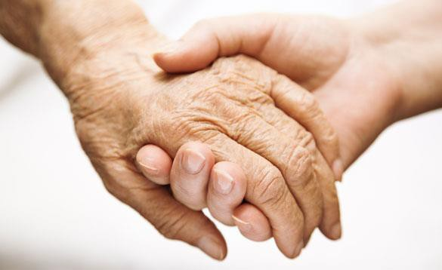
- As the older adult population grows, more professionals with experience in Gerontology will be needed.
- Coursework in aging can make you more marketable! All majors can benefit from having aging-related coursework, such as: Psychology, Sociology, Health Science, Nursing, Biological Science, Kinesiology, Economics, Anthropology, Marketing, and more!
Course Description
Multidisciplinary overview of: characteristics, strengths and problems of older persons; aging theories and how the body ages, diversity in aging process involving gender, race, ethnicity, subculture; services to older adults; gerontology as an academic discipline and a field of practice. (GERO 133, SOCI 133, HESC 133, HUSR 133 and PSYC 133 are the same course; students can enroll in any section.)

