Join to Graduate with Honor and Distinction!

Gerontology is one of the TOP TEN fastest growing fields!
Join the Gerontology Honor Society (Sigma Phi Omega) at CSUF and become part of a national network of professionals
and students in the field of aging!
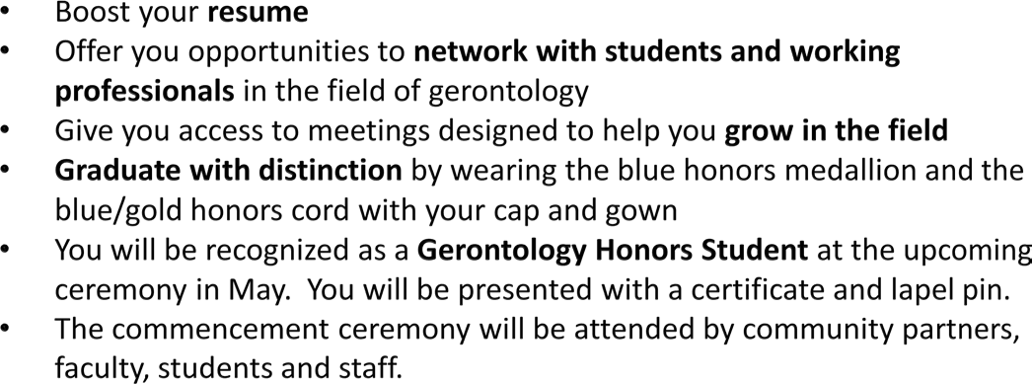
Don’t wait! Join today and reap the benefits!
Become a member online at www.sigmaphiomega.org

SPO is the national academic honor and professional society in gerontology, established in 1980 to recognize excellence of those who study and work in the field of aging.
WHY JOIN SPO?

HONOR SOCIETY IN GERONTOLOGY
By joining SPO you will be able to network with fellow students, educators, practitioners, and administrators in the field. You will also be able to participate in the leadership of SPO to help organize events and serve the community and other Gerontology students.
WHO CAN JOIN?
- Undergraduate and graduate students who are majoring or minoring in gerontology/aging studies and related fields.
- Students must be in at least their second term of enrollment.
- UNDERGRADS: Must has average GPA of at least 3.3.
- GRAD STUDENTS: Must have a grade point average of at least 3.5.
HOW DO I SIGN UP?
To fill out a membership application, go to sigmaphiomega.org, scroll over the “About Us” tab and click “Become a Member”

