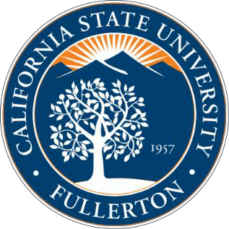
Masters of Science
in Gerontology

WHY PURSUE A MASTER’S IN GERONTOLOGY AT CSUF?
The emerging field of gerontology is the study of aging from a multi-disciplinary perspective. The unprecedented growth of the older population has created a growing demand for well-trained specialists with expertise in gerontology.

At CSUF, the Master of Science in Gerontology (MSG) provides students with a strong foundation in both applied and theoretical gerontology, with an emphasis on biological, psychological, and social aspects of aging. Our program prepares students to serve the growing aging population in a variety of settings from business to government to health and human services. Our alumni serve as practitioners, educators, researchers, advocates, and policy makers.

The MSG at CSUF is offered through the Gerontology Academic Program. This unique program is composed of dozens of faculty representing diverse academic disciplines, exposing students to a wide variety of course offerings and research opportunities.

ADMISSION PROCEDURES

Students must fill out both a university application and a gerontology application. Requirements for admission include:
- A bachelor’s degree in gerontology or in a related field with an undergraduate minor, certificate or emphasis in gerontology, or the equivalent. In the absence of these, the application must have 12 units of upper-division coursework in gerontology, or their equivalent, and have completed a statistics course
- A grade-point average of at least 3.0 in gerontology-related coursework
- Three (3) letters of recommendation
- A letter from the student stating professional objectives
- Written Critical Thinking Assessment
- Interview with gerontology faculty members

In addition, the following factors will be taken into consideration:
- Previous paid or volunteer experience in working with older adults
- Research experience

DEGREE REQUIREMENTS

The MSG requires 30 units of approved graduate work with a minimum of 21 units at the 500 level.

- Core Courses (18 units)

Gerontology 500 Applied Gerontology/Professional Development (3)
- Gerontology 501 Research Methods in Gerontology (3)
- Gerontology 503 Aging and Public Policy (3)
- Gerontology 507 Biopsychosocial Aging (3)
- Gerontology 535 Evaluation and Program Planning (3)
- Gerontology 595 Gerontology Internship (3)

- Electives (9 units)

Electives are offered directly through the gerontology program or are cross-listed with other departments. Given that gerontology is a multidisciplinary program, students are required to take, in addition to gerontology-housed electives, electives from some of these other departments. Current elective options can be found on the CSUF Gerontology home page.

- Thesis or Project (3 units) Take at least one of the following:

Gerontology 597 Project (3)
- Gerontology 598 Thesis (3)

CONTACT US

Humanities Building, Suite 424 (H-424) (657) 278-7057
gerontology@fullerton.edu

